Microsoft Azure - Starter Kits for Partners

Introduction to Starter Kits

Azure Site Recovery

Last Update: August 2015





**MICROSOFT MAKES NO WARRANTIES, EXPRESS, IMPLIED OR STATUTORY, AS TO THE INFORMATION IN THIS DOCUMENT.**

The information contained in this document represents the current view of Microsoft Corporation on the issues discussed as of the date of publication. Because Microsoft must respond to changing market conditions, it should not be interpreted to be a commitment on the part of Microsoft, and Microsoft cannot guarantee the accuracy of any information presented after the date of publication.

Complying with all applicable copyright laws is the responsibility of the user. Without limiting the rights under copyright, no part of this document may be reproduced, stored in or introduced into a retrieval system, or transmitted in any form or by any means (electronic, mechanical, photocopying, recording, or otherwise), or for any purpose, without the express written permission of Microsoft Corporation.

Microsoft may have patents, patent applications, trademarks, copyrights, or other intellectual property rights covering subject matter in this document. Except as expressly provided in any written license agreement from Microsoft, the furnishing of this document does not give you any license to these patents, trademarks, copyrights, or other intellectual property.

The descriptions of other companies’ products in this document, if any, are provided only as a convenience to you. Any such references should not be considered an endorsement or support by Microsoft. Microsoft cannot guarantee their accuracy, and the products may change over time. Also, the descriptions are intended as brief highlights to aid understanding, rather than as thorough coverage. For authoritative descriptions of these products, please consult their respective manufacturers.

© 2015 Microsoft Corporation. All rights reserved. Any use or distribution of these materials without express authorization of Microsoft Corp. is strictly prohibited.

Microsoft and Windows are either registered trademarks of Microsoft Corporation in the United States and/or other countries.

The names of actual companies and products mentioned herein may be the trademarks of their respective owners.

Contents

Overview 4

The Disaster Recovery Problem 4

The Proposed Solution 5

The Value of Microsoft Azure Site Recovery 8

Partner Needs 8

Introduction to Starter Kits 9

Starter Kits - Partner Benefits 9

# Overview

In this document, we will cover the challenges our customers are facing with Business Continuity and Disaster Recovery (BCDR) to protect their on-premises physical servers and virtual machines and how Microsoft Azure can help them to solve this problem. Finally, we introduce the concept of a “Starter Kit”, essentially demonstrate how to leverage this concept of a packaged offering to accelerate the Partner sales and deployment cycle.

# The Disaster Recovery Problem

As an IT Administrator, you need to assure the continuity of the operations on the company and prepare a **Disaster Recovery Plan in case of an emergency**. An information technology disaster recovery plan (IT DRP) should be developed in conjunction with the business continuity plan. Priorities and recovery time objectives for information technology should be developed during the business impact analysis. Technology recovery strategies should be developed to restore hardware, applications and data in time to meet the needs of the business recovery.

The recovery time for an IT resource should match the **recovery time objective** for the business function or process that depends on the IT resource.

Information technology systems require hardware, software, data and connectivity. Without one component of the “system,” the system may not run. Therefore, recovery strategies should be developed to anticipate the loss of one or more of the following system components:

* Computer room environment (secure computer room with climate control, conditioned and backup power supply, etc.)
* Hardware (networks, servers, desktop and laptop computers, wireless devices and peripherals)
* Connectivity to a service provider (fiber, cable, wireless, etc.)
* Software applications (electronic data interchange, electronic mail, enterprise resource management, office productivity, etc.)
* Data and restoration

Some business applications cannot tolerate any downtime. They utilize dual data centers capable of handling all data processing needs, which run in parallel with data mirrored or synchronized between the two centers. This is a very expensive solution that only larger companies can afford. However, there are other solutions available for small to medium sized businesses with critical business applications and data to protect.

Disaster recovery is based on replication, a technology with a rich history. Replication mirrors data across a network, either in real time (continuous replication) or at intervals (snapshot-based replication). The technology is typically used to move data from a local source location to one or more remote target locations.

Replication and DR have their origins in maintaining data integrity and availability of storage-based data. However, in the virtualized environments of today, the distinctions between protecting a VM (or a group of VMs on a given server) and replicating one or more VMs to recover the data a VM contains in case of a disaster are becoming blurry.

# The Proposed Solution

In response to many customer requests for DR on Microsoft Azure, Microsoft developed Azure Site Recovery (ASR), which enables the failover of Hyper-V and VMware VMs, as well as physical instances that are running on-premises to Microsoft Azure. Azure Site Recovery protects mission-critical applications with automated replication-based DR of physical and virtual machines. Servers can be protected to targets that are on-premises, at a hosting service provider, or on the Azure cloud. Microsoft is essentially entering the DRaaS market with ASR by enabling failover of a VM or physical machine to Azure, providing customers — SMBs, enterprises, and HSPs — with the ability to achieve DR without needing to invest in a costly duplicate infrastructure.

**How ASR Works**

The ASR tool itself resides on Microsoft Azure and remotely monitors VMs in a customer's datacenter on an ongoing basis. Recovery Plans, which contain IT recovery instructions in case of an outage, such as which server and service to bring back first and how fast, are kept in the Azure Management Portal. IT has the ability to design very simple recovery plans or highly customized scenarios using PowerShell scripts.

Unlike in traditional DR environments, IT can use ASR to test recovery plans as often as desirable without causing disruptions in the operational infrastructure. The testing is noninvasive and can be done without the cost, complexity, and downtime of a traditional DR test.

ASR comes with encryption capabilities. Replicating to Azure requires a Site Recovery Vault on Azure; however, no live VMs are needed, as a failover automatically spins up the required VMs. This is a cost benefit to customers, not only because they do not need to pay for running the VMs in Azure but also because they save on licensing fees for Microsoft workloads through DR benefits covered under Microsoft's Software Assurance (SA). For each licensed instance customers run, the SA allows them to run one instance of the software on a backup server for disaster recovery.

**ASR Advantages for Midsize Firms**

Microsoft believes that it delivers several distinct advantages compared with other DRaaS providers. For midsize, companies, these benefits are:

* Targeted pricing, because midsize firms cannot always afford traditional DR services:
  + ASR using Hyper-V but without VMM is available without requiring System Center or System Center VMM. There are no up-front costs or termination fees, and users "pay only for what they use." This offering should also attract small businesses that typically do not have VMM or System Center.
  + ASR with VMM requires System Center (and System Center VMM), but this is arguably still a more cost-effective approach for medium-sized companies than engaging traditional DR services to protect their mission-critical workloads.
* The ability to protect as few or as many VMs as the business requires, whether 2 or 2,000, a level of scalability that Microsoft believes is a differentiator and beneficial for smaller firms.

**ASR Advantages for Large Enterprises**

For large enterprises, which may have tier 1 workloads well protected already, benefits include:

* ASR provides an affordable opportunity to protect lower-tier workloads and remote office and branch office applications, which are neglected at many enterprises.
* Enterprises that are about to renew their agreements with DR providers might want to do a comparative assessment between ASR and their current provider to decide whether they could benefit from Microsoft's DRaaS offering.
* Enterprise customers can take advantage of Azure Site Recovery leveraging InMage technology, described in more detail in the section that follows, which provides DR for heterogeneous IT environments.
* Enterprises can take advantage of adding storage array–based replication between SAN devices that host virtual machine data for their tier 1 workloads. With the same solution, enterprises can manage their tier 1 workloads requiring synchronous replication from array-based replication as well as other workloads that can be protected with software-based near synchronous replication.

**Current ASR Scenarios**

This table summarizes the replication scenarios supported by Site Recovery.

| **REPLICATE** | **REPLICATE FROM** | **REPLICATE TO** | **ARTICLE** |
| --- | --- | --- | --- |
| VMware virtual machines | On-premises VMware server | Azure storage | [Deploy](https://azure.microsoft.com/en-us/documentation/articles/site-recovery-vmware-to-azure-classic/) |
| Physical Windows/Linux server | On-premises physical server | Azure storage | [Deploy](https://azure.microsoft.com/en-us/documentation/articles/site-recovery-vmware-to-azure-classic/) |
| Hyper-V virtual machines | On-premises Hyper-V host server in VMM cloud | Azure storage | [Deploy](https://azure.microsoft.com/en-us/documentation/articles/site-recovery-vmm-to-azure/) |
| Hyper-V virtual machines | On-premises Hyper-V site (one or more Hyper-V host servers) | Azure storage | [Deploy](https://azure.microsoft.com/en-us/documentation/articles/site-recovery-hyper-v-site-to-azure/) |
| On-premises Hyper-V virtual machines | On-premises Hyper-V host server in VMM cloud | On-premises Hyper-V host server in VMM cloud in secondary datacenter | [Deploy](https://azure.microsoft.com/en-us/documentation/articles/site-recovery-vmm-to-vmm/) |
| Hyper-V virtual machines | On-premises Hyper-V host server in VMM cloud with SAN storage | On-premises Hyper-V host server in VMM cloud with SAN storage in secondary datacenter | [Deploy](https://azure.microsoft.com/en-us/documentation/articles/site-recovery-vmm-san/) |
| VMware virtual machines | On-premises VMware server | Secondary datacenter running VMware | [Deploy](https://azure.microsoft.com/en-us/documentation/articles/site-recovery-vmware-to-vmware/) |
| Physical Windows/Linux server | On-premises physical server | Secondary datacenter | [Deploy](https://azure.microsoft.com/en-us/documentation/articles/site-recovery-vmware-to-vmware/) |

These are summarized in the following diagrams.

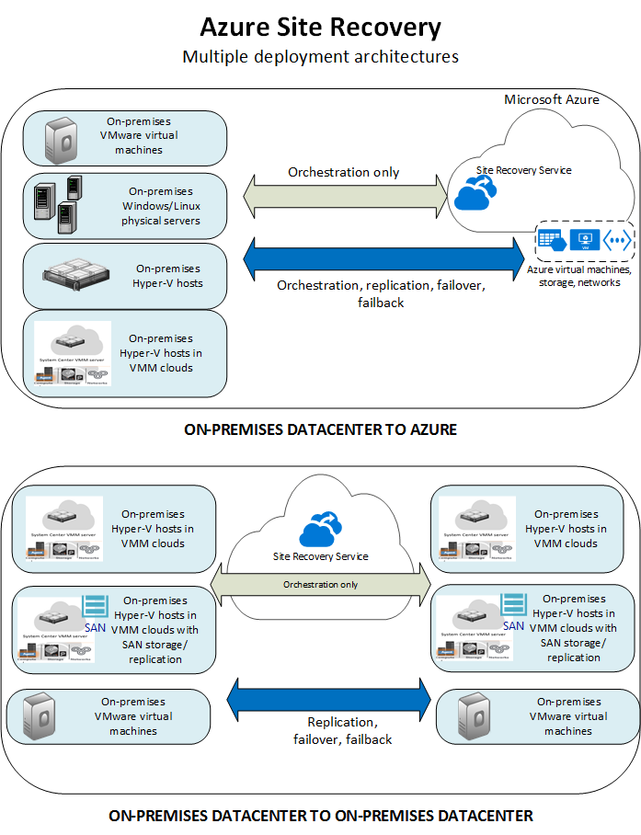

Site Recovery replication technologies are compatible with any application running in a virtual machine. In addition, we've done additional testing in partnership with application product teams to further support each app.

|  |  |  |  |  |
| --- | --- | --- | --- | --- |
| Workload | Replicate Hyper-V VMs  (to a secondary site) | Replicate Hyper-V VMs  (to Azure) | Replicate VMware VMs  (to a secondary site) | Replicate VMware VMs  (to Azure) |
| Active Directory, DNS | Y | Y | Y | Y |
| Web apps (IIS, SQL) | Y | Y | Y | Y |
| SCOM | Y | Y | Y | Y |
| Sharepoint | Y | Y | Y | Y |
| SAP  Replicate SAP site to Azure for non cluster | Y (tested by Microsoft) | Y (tested by Microsoft) | Y (tested by Microsoft) | Y (tested by Microsoft) |
| Exchange (non-DAG) | Y | Coming soon | Y | Y |
| Remote Desktop/VDI | Y | Y | Y | N/A |
| Linux  (operating system and apps) | Y (tested by Microsoft) | Y (tested by Microsoft) | Y (tested by Microsoft) | Y (tested by Microsoft) |
| Dynamics AX | Y | Y | Y | Y |
| Dynamics CRM | Y | Coming soon | Y | Coming soon |
| Oracle | Y (tested by Microsoft) | Y (tested by Microsoft) | Y (tested by Microsoft) | Y (tested by Microsoft) |
| Windows File Server | Y | Y | Y | Y |

# The Value of Microsoft Azure Site Recovery

**Time to Market:** Microsoft Azure helps companies get their needs covered faster. With no need to wait on IT to provision hardware, resources are available immediately to be effective right away.

**Economics:** Microsoft Azure helps reduce IT expenditure by eliminating infrastructure purchase and maintenance costs. Pay only for the use and benefit from economies of scale that come from taking advantage of large-scale data centers in the cloud

Value for Partners and Customers:

* Minimal investment, since no secondary site is needed
* Reduced operational expenses with shift to cloud recovery and automation, including assured recovery of applications and systems
* New high availability and disaster recovery options
* Data sovereignty with geo-replicated off-site storage
* Reduced data loss (RPO), reduced implementation time, and increased speed of recovery (RTO) with premium service-level agreements
* Familiar tools used across a common platform that make the solution easier to embrace

# Partner Needs

Partners want to make profitable businesses by deploying and selling Microsoft Azure.

They also want to sell and deploy Azure Site Recovery Scenarios, but do not have the experience or understanding to say what is possible or know possible ways to sell the value of it or set it up.

Most of our partners have customers who are spending millions on enterprise-grade infrastructure to run their Line of Business Applications, they could become a trusted advisor if they provide a single solution to provide disaster recovery.

Microsoft Azure offers:

* A clear path to success with a fast track to new lines of business
* A flexible platform
* A familiar ecosystem designed to help get partner solutions and services to market quickly
* Flexible pricing options and support for partners serving a range of customers, from small and midsize business to enterprise organizations

# Introduction to Starter Kits

This concept is a set of deliverables, packaged as an offering that are named as a starter kit. Starter kits are designed to show a partner a specific scenario in Azure that could be possible for them to build and equip them in the technical sales cycle. Each kit will include:

1. A Description of the partner benefit for using and participating in the kit.
2. An assessment questionnaire and guidance that Partners could use with a customer.
3. An Architecture Topology presentation for a recommended way to implement the specified scenario.
4. A cost estimator (based on retail pricing) for implementing the recommended scenario on Azure.
5. A Statement of Work template for implementing the recommended scenario that a partner could use.
6. Hands on Labs a Partner can self-study to build technical skill implementing the recommended scenario.

# Starter Kits - Partner Benefits

1. Reduce time in creating a proposal for a customer through a sale and deployment template
2. Reduce the learning curve cost by focusing on a proven scenario
3. Help assess and determine the technical requirements to get a correct dimensioning of the Site Recovery scenario.
4. Sell, estimate cost and deploy working solutions to your customer.
5. Get tools and templates to use when discussing a Site Recovery with your customers.
6. Receive a recommended set of topology diagrams to implement a Disaster Recovery scenario on Azure.
7. Receive guidance for self-study to learn the recommended Azure Site Recovery scenario.